Assignment – 6
Task -1
Description:
• Use AI to complete a Student class with attributes and a method.
• Check output.
• Analyze the code generated by AI tool.

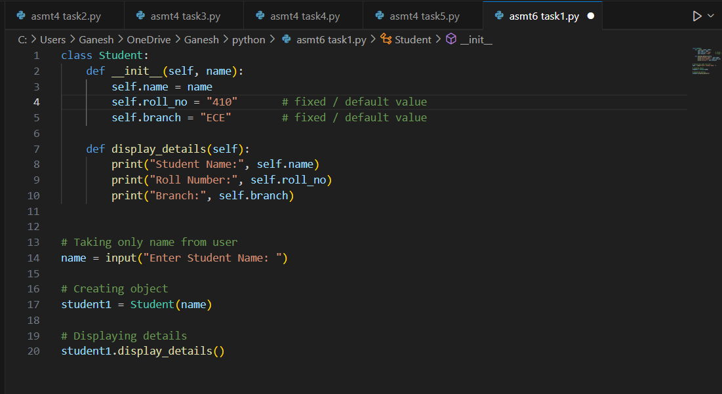
Expected Output: Class with constructor and display_details() method
Practical Output:

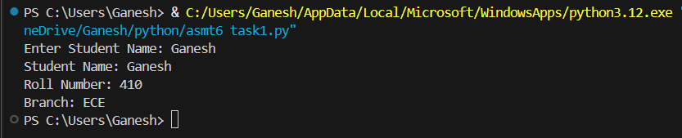

Task – 2
Description:
• Prompt AI to complete a function that prints the first 10 multiples of a number using a loop.
• Analyze the generated code
• Ask AI to generate code using other controlled looping

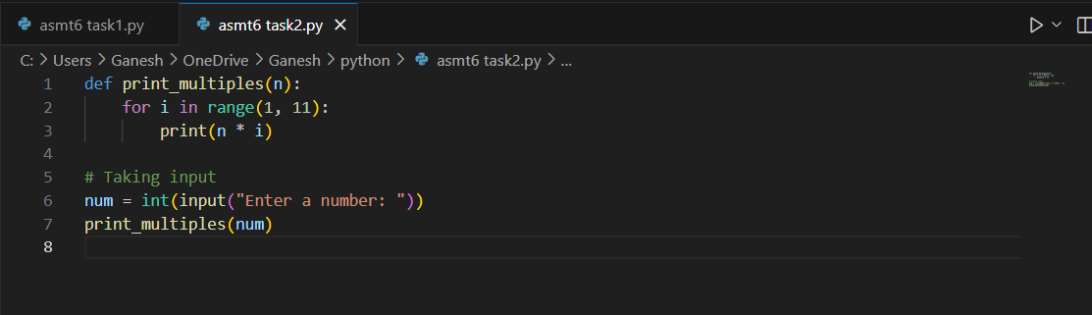
Expected Output: Correct loop-based implementation
Practical Output:

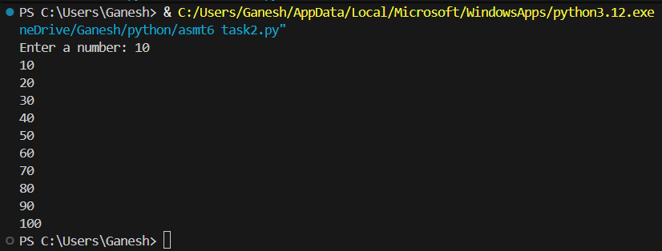

Task – 3
Description:
• Ask AI to write nested if-elif-else conditionals to classify age groups.
• Analyze the generated code
• Ask AI to generate code using other conditional statements

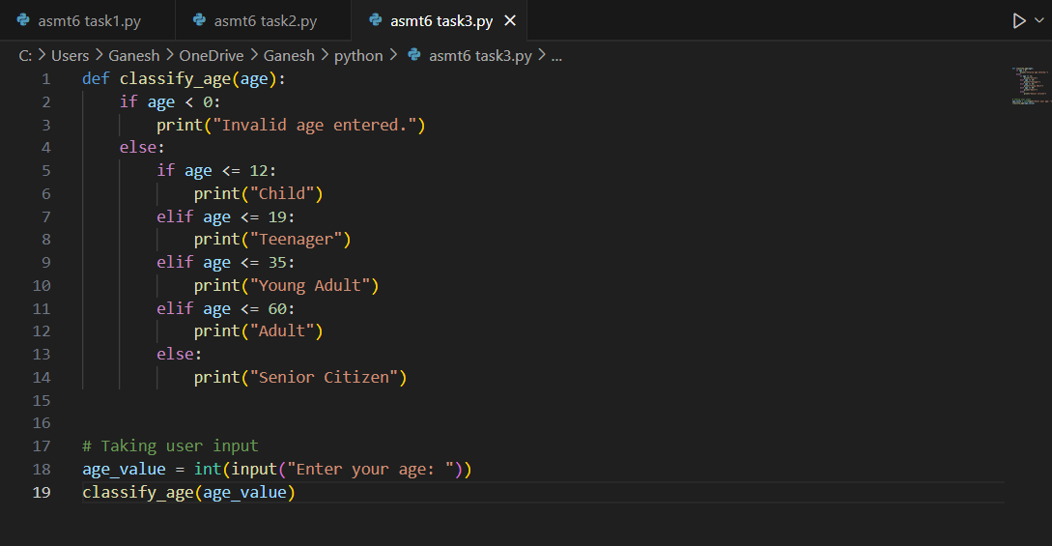
Expected Output: Age classification function with appropriate conditions and with explanation
Practical Output:

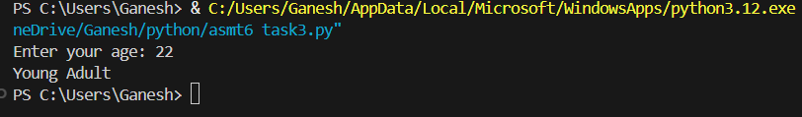

Task – 4
Description: (For and While loops)
• Generate a sum_to_n() function to calculate sum of first n numbers
• Analyze the generated code
• Get suggestions from AI with other controlled looping

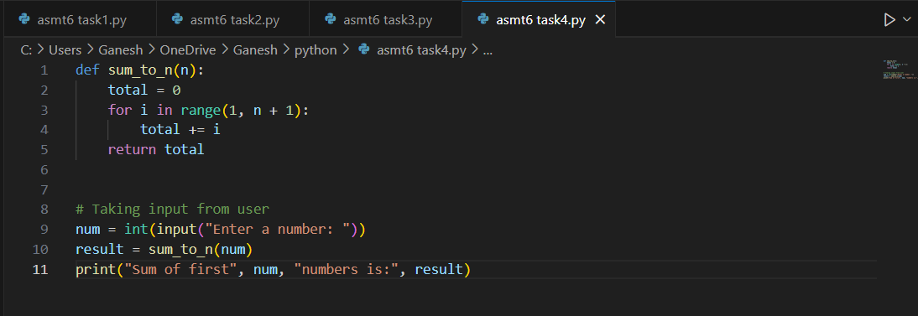
Expected Output: Python code with explanation.
Practical Output:

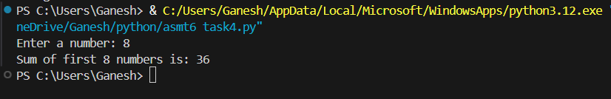

Task - 5
Description: (Class)
• Use AI to build a BankAccount class with deposit, withdraw, and balance methods.
• Analyze the generated code
• Add comments and explain code

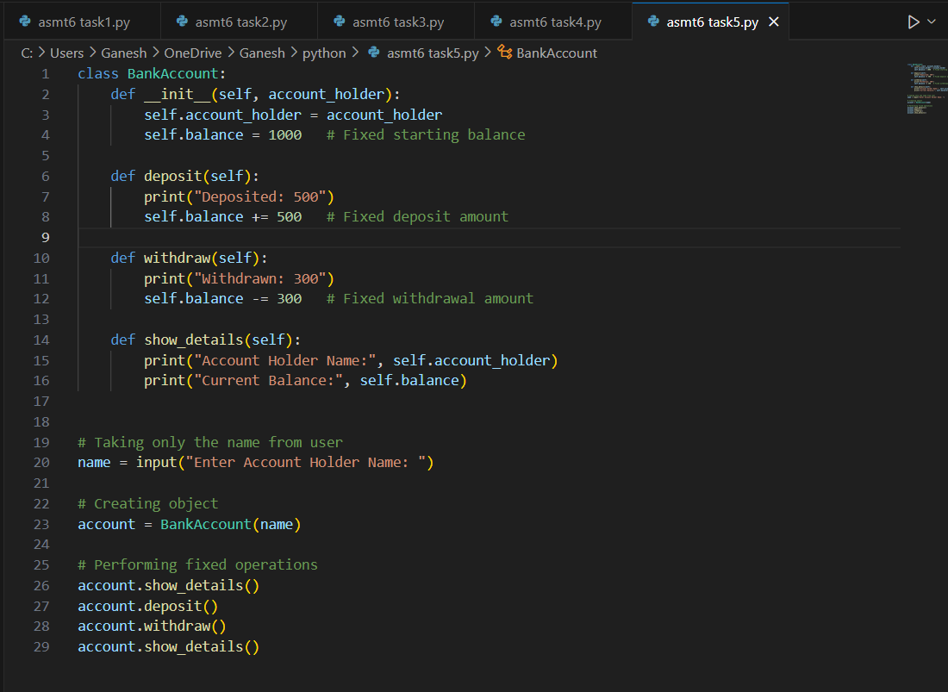
Expected Output: Python code with explanation.
Practical Output:

